Assignment 10.1

1.Write a program to implement wordcount using Pig. Share the screenshots of the commands used with its associated output.

Program

A = load ‘/home/acadgild/wc.txt’ as (c1:chararray);

B = foreach A generate flatten(Tokenize((chararray)$0)) as word;

C = group B by word;

D = foreach C generate group,COUNT(B.word);

dump D;

Input text file for word count program.

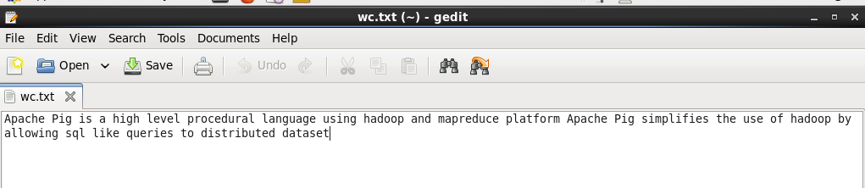

Word count program

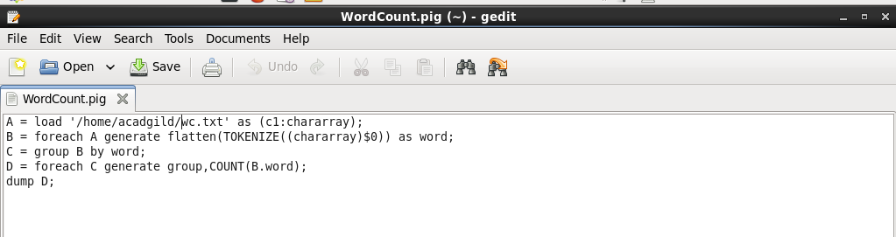

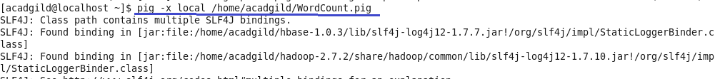

Output

